Day 14
Task 2
Snawflake hands-on demo

- Creating a snowflake trail account and create a warehouse
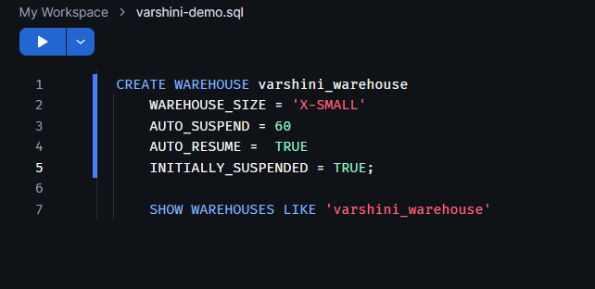
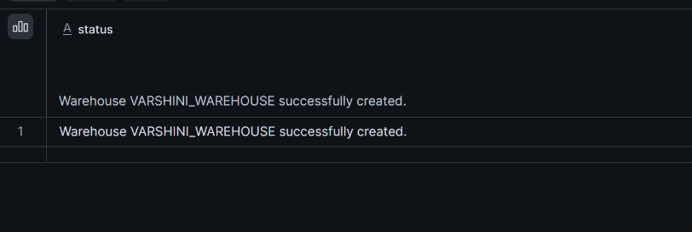

2. Create a database and schema 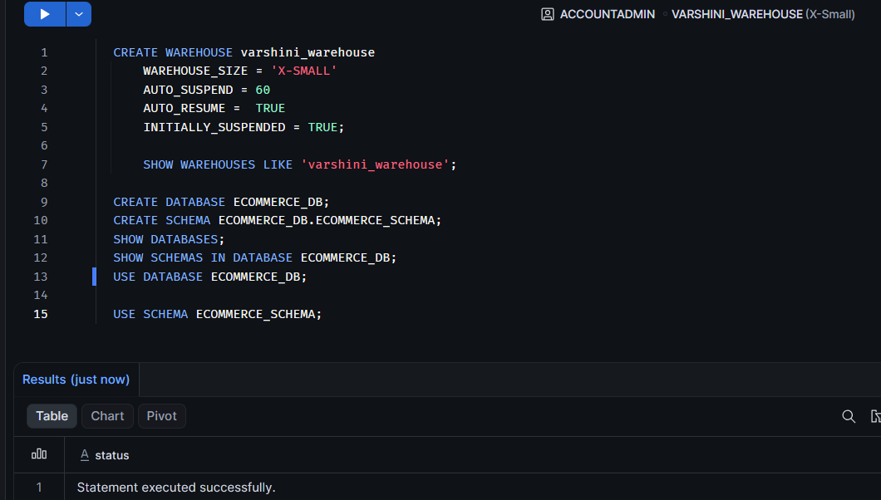

3.Create a table inside the schema
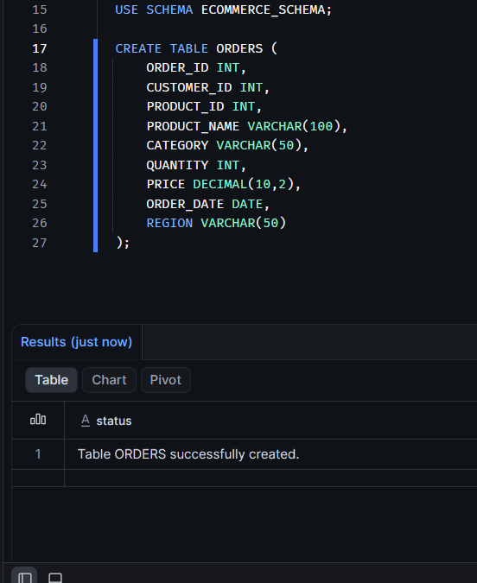

Show tables:
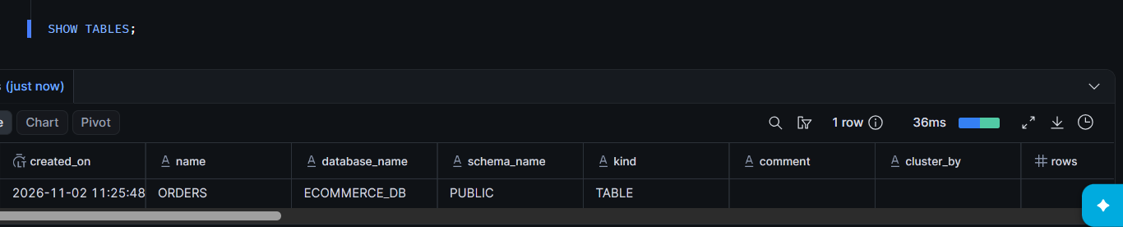
View table structure:
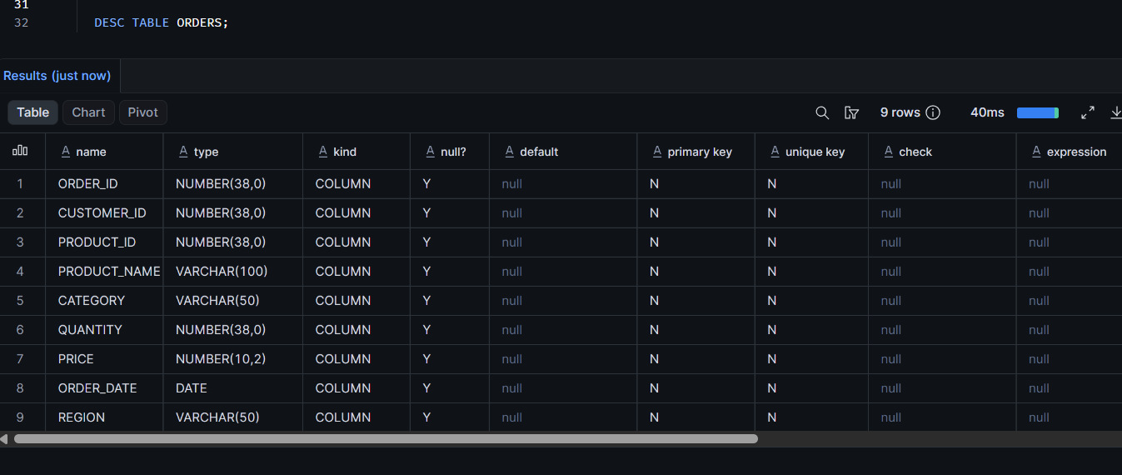
Create a file format

Create CSV file format:
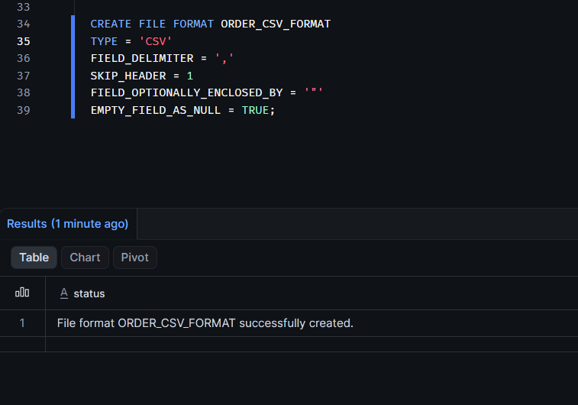

Create a stage
Create an internal stage for uploading the dataset:
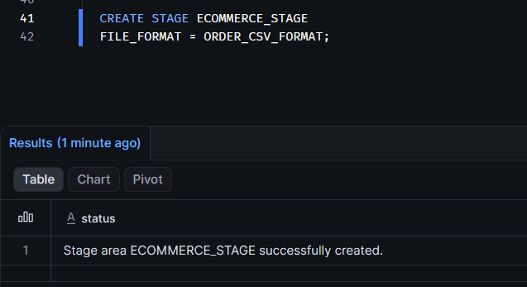

7. Upload the dataset
Upload the CSV dataset through the Snowflake interface:
- Navigate to Databases.
- Select ECOMMERCE_DB.
- Open ECOMMERCE_SCHEMA.
- Select Stages.
- Open ECOMMERCE_STAGE.
- Click Upload Files.
- Select your CSV dataset and upload it.
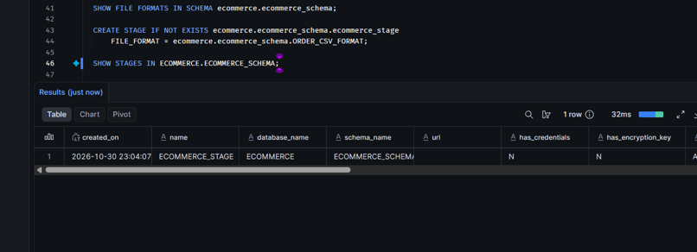

8. Load data into the table
Copy the uploaded CSV data into the ORDERS table:

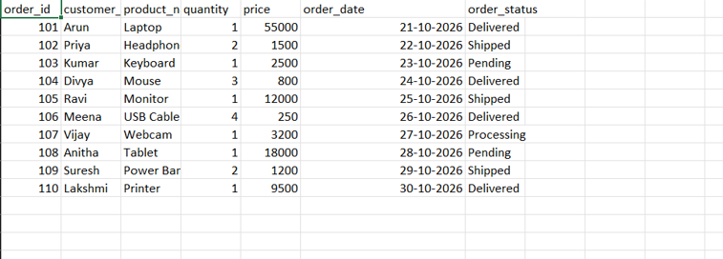
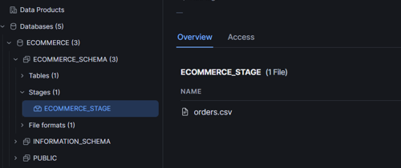
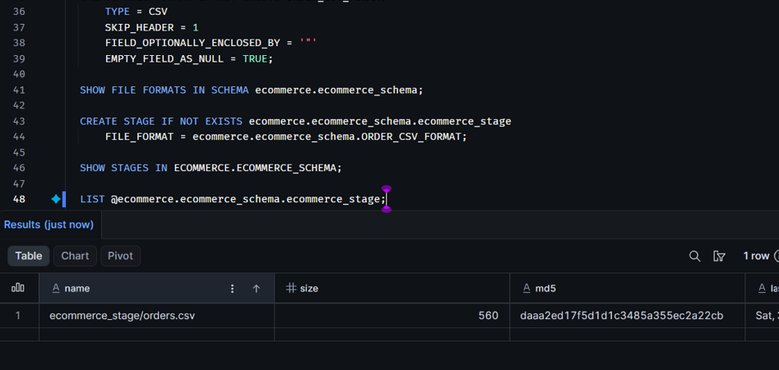

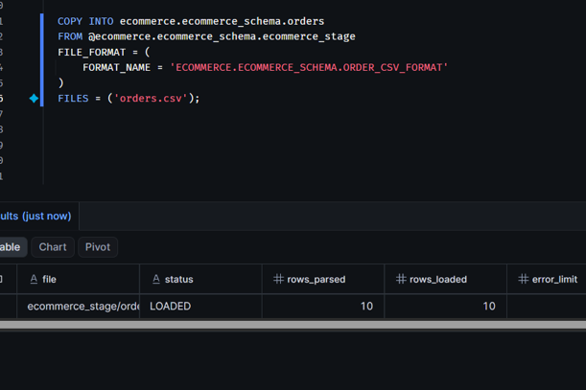
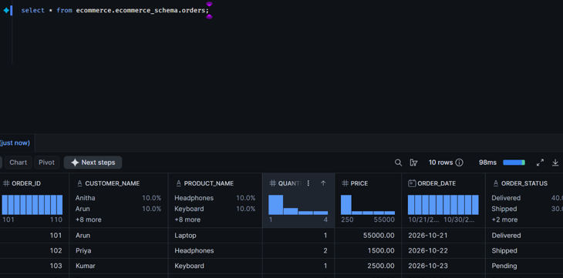

Grouping and charts in snowflake
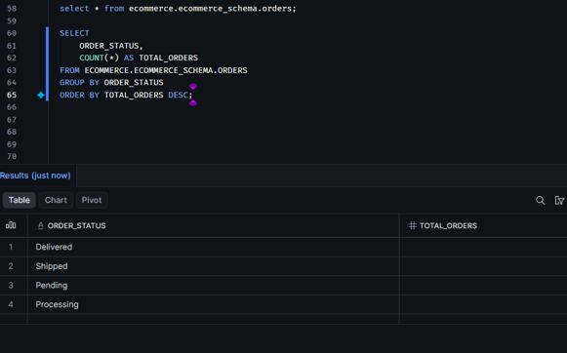
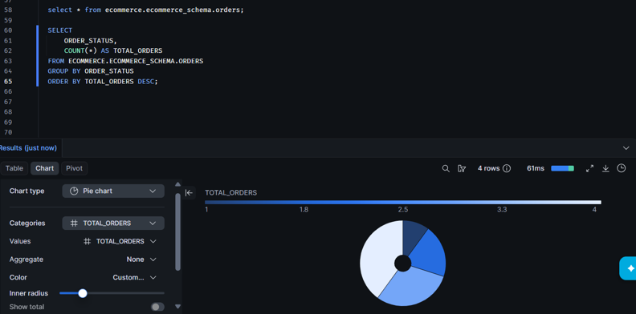

Final verification commands
SHOW WAREHOUSES;

SHOW DATABASES;

SHOW SCHEMAS IN DATABASE ECOMMERCE_DB;

SHOW TABLES IN SCHEMA ECOMMERCE_DB.ECOMMERCE_SCHEMA;

SHOW STAGES;

SHOW FILE FORMATS;

SELECT COUNT(*) FROM ORDERS;

SELECT * FROM ORDERS LIMIT 10;

